Name: Saimeera D
Reg. No.: 192524405
CLOUD COMPUTING
LAB PROGRAMS

1.a. Execute a Python Program in Google Cloud Shell

AIM: Run a Python application using a cloud-based environment.
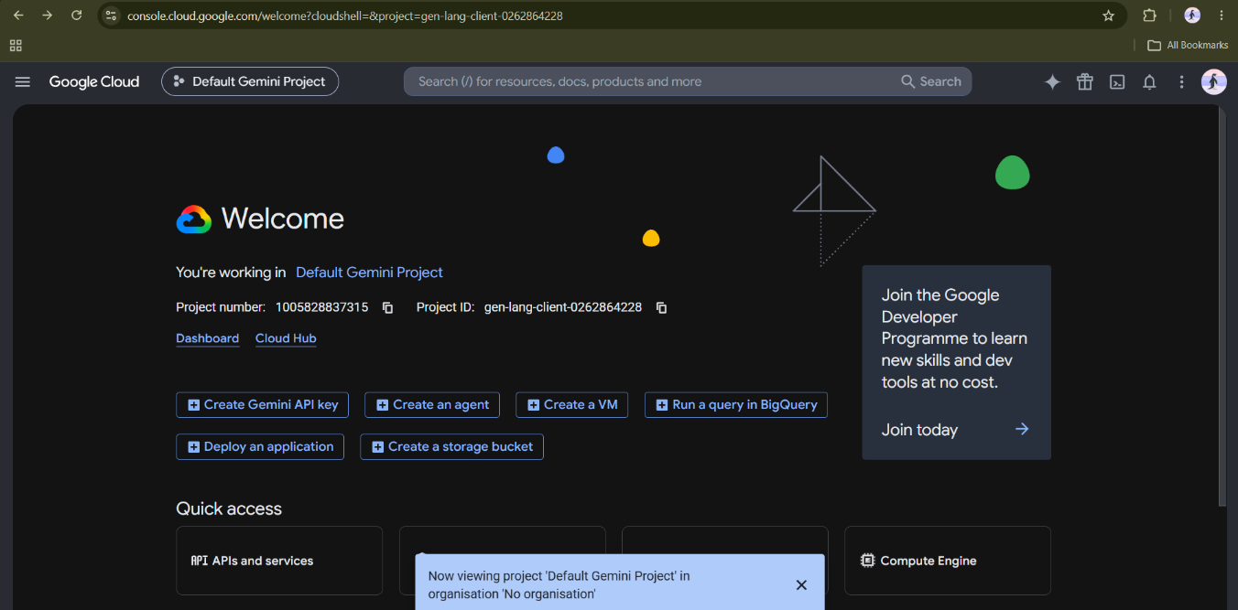
GOOGLE CLOUD HOME PAGE
AUTHORIZE CLOUD SHELL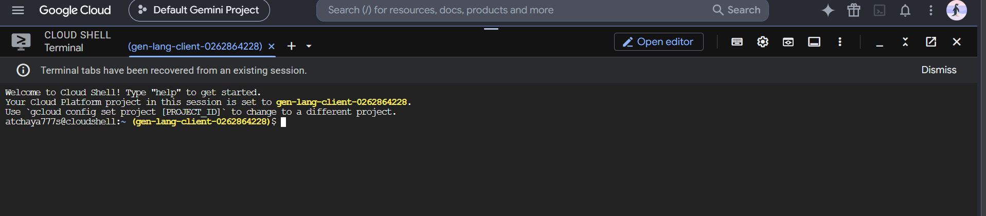
NANO HELLO.PY
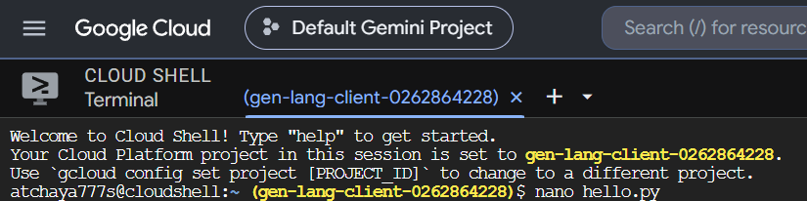

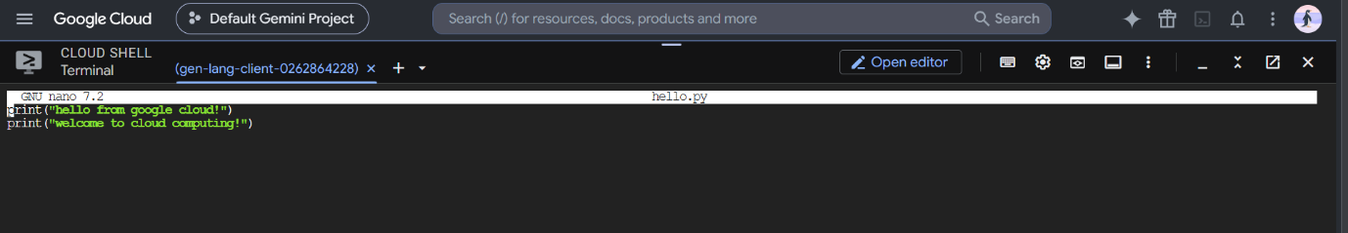
PYTHON CODING

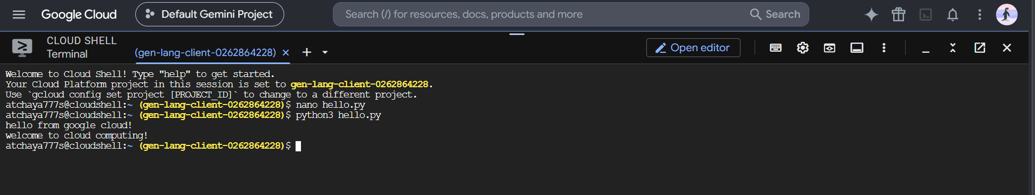
EXECUTE & OUTPUT

1.b Addition of two numbers using python in Google Cloud Shell

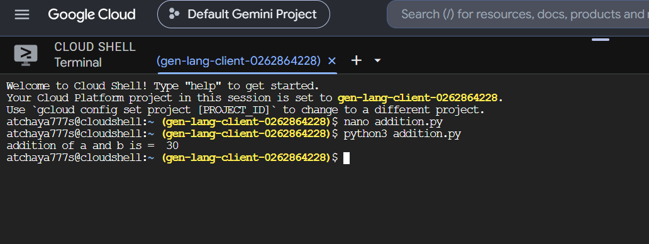
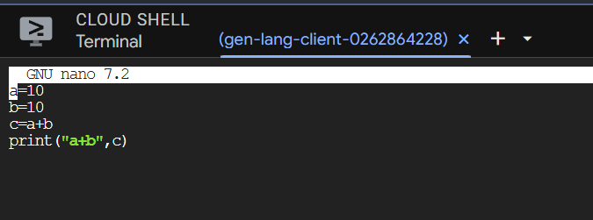

2. Create and Manage Files in Cloud Storage of Cloud Shell
Aim: Demonstrate cloud-based file creation and management.
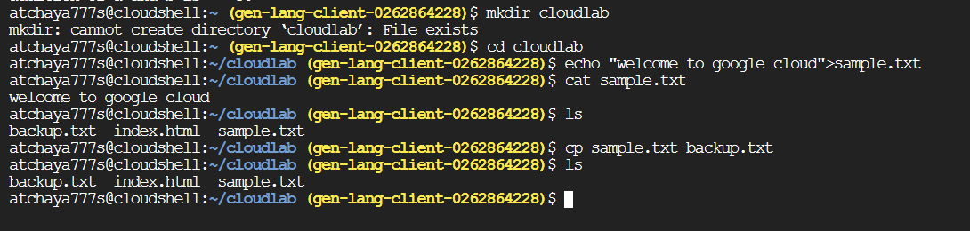

3. Run a Simple Web Server in Google Cloud Shell
Aim: Host and access a simple webpage from a cloud development environment.
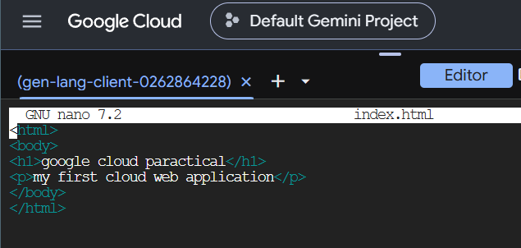

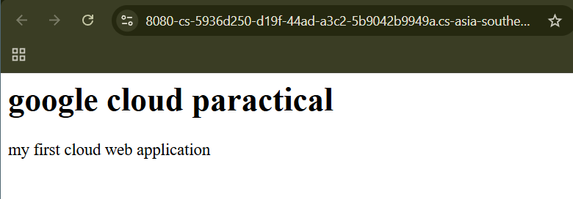

4. System Resource Monitoring in Google Cloud Shell
Aim: Demonstrate monitoring of CPU, memory and storage resources in a cloud environment.
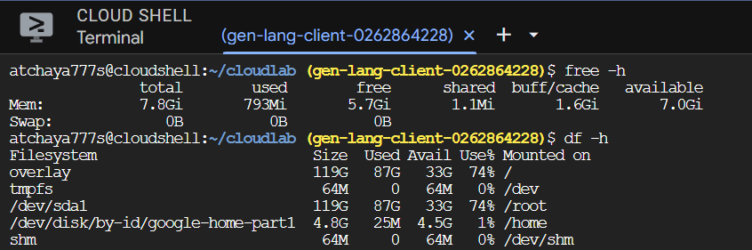
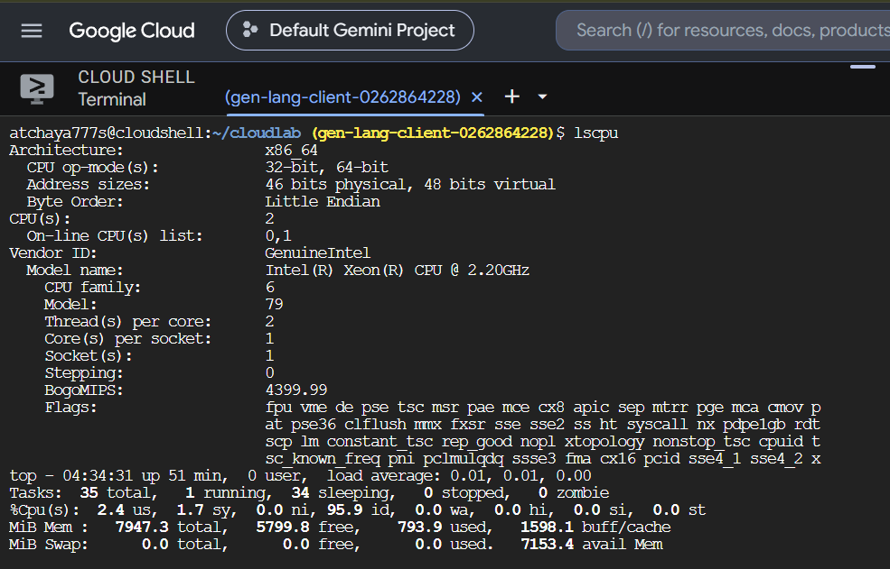

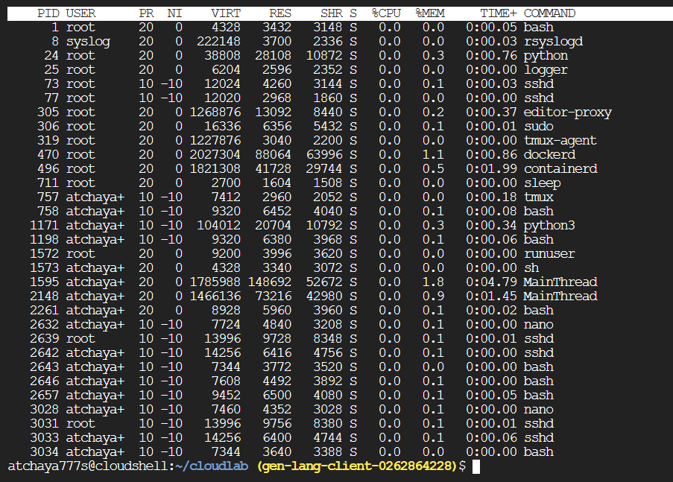
5. Execute a C Program in Google Cloud Shell
Aim: Compile and execute a C application in a cloud-based environment.
Create program


